*Florida International University*

*School of Computing and Information Sciences*

Software Engineering Focus

Feature Document

User Story ID #994

**Name: Open Notification**

**Team Member: Alvaro Silva**

**Project: SkillCourt 7.0**

**Product Owner(s)**: Guðmundur Traustason

**Mentor(s)**: Masoud Sadjadi

**Instructor**: Dr. Masoud Sadjadi

**Open Notification:**

* Description: **As a** User **I would like** to open notification **so that** I can open a interface where I can accept or decline the game invitation.

Acceptance Criteria

* Phone can receives notifications

**Use Case**

* Name: Open Notification
* Actor: Player
* Preconditions: Notification is received ***and***

Notification is displayed in the phone

* Description <Flow of events>:

|  |  |
| --- | --- |
| Actor Steps | System Steps |
| 1. Actor clicks in the notification. |  |
|  | 2. System opens the SkillCourt app. |
|  | 3. System shows a window to accept or decline invitation. |

**Use Case Diagram**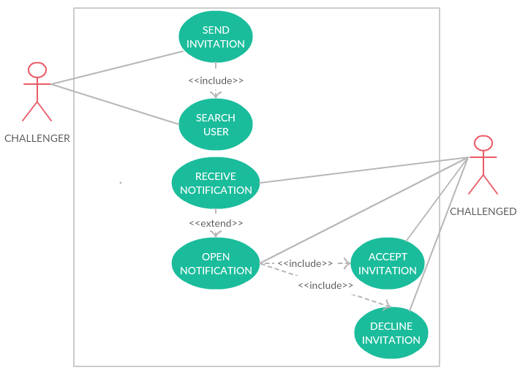

**Sequence Diagram**

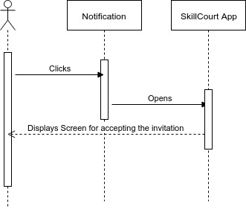

**Unit Test**

* Test case ID:
* Description/Summary of Test: Test if the implementation for opening the UI for accepting the invitation.
* Pre-condition: SkillCourt app running.
* Expected Results: Opens the app and displays the UI for accepting the invitation.
* Actual Result: Opens the app, and displays the correct UI.
* Status (Fail/Pass): Pass.

**Visual User Guide**

